PHASE OFFSET ESTIMATION FOR QAM DEMODULATION

Should a quadrature amplitude modulation (QAM) message pair be encountered in the Lab 5 data file lab5_RedHerring.mat, the instructions for Lab 5 suggest a manual search procedure to discover by trial and error the correct coherent phase offset to use in the cosine and sine demodulation frequencies in order to separate the two message channels within the QAM modulated signal. This supplement describes an alternative procedure to directly estimate the phase offset, avoiding the need for a manual search. You will need to turn the technical information in this supplement into appropriate Matlab code for application to the lab data if you find a QAM component in the data.

As discussed in the class lecture notes and textbook, a QAM modulator of dual message signals generates, using in-phase (cosine) and in-quadrature (sine) [I/Q] modulations of 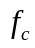Hz applied to the audio messages 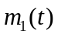and 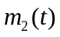, the transmitted signal
Whether transmitted by wire or wireless, the QAM demodulator will receive a time-delayed signal
The unknown time delayincludes both the propagation time delay and the delay due to processing that occurs prior to the QAM demodulator, such as the band-pass filter (BPF) used to isolate the QAM channel within a FDM signal. If this delayed signal is sampled at 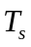second intervals in order to implement a digital QAM demodulator, the discrete-time signal will have the form
in which 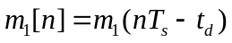, 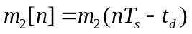, and 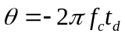is the unknown phase offset due to the unknown delay. This is the input shown in Figure 1 (a)-(c) for the QAM demodulator.

If we do not adjust for the unknown phase offset when demodulating the QAM signal with a cosine and a sine of frequency , the resulting waveforms [after the low-pass filter (LPF) that deletes the modulated replicants at 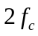 Hz] in the I-branch and Q-branch of the QAM demodulator will respectively be (see class lecture notes)

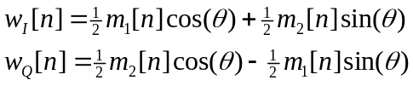
as shown in Figure 1(a). Thus, the QAM demodulator fails to separate the audio messages if there is no adjustment for the phase offset, since portions of both messages are contained in each branch.
It is clear from the equation pair for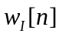and 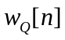 that there is information on the phase offset contained within the I and Q branch signals if we can devise a method to exploit the I/Q structure of the signal pair. Consider the polar-coordinate re-definitions
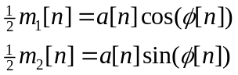
for each time sample index n. The values of positive real amplitude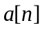and phase 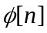 can be obtained simply as
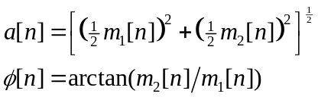
With these re-definitions, then
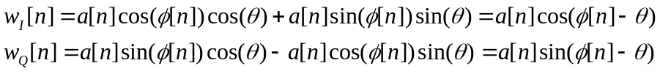
Application of the arctangent function will then yield
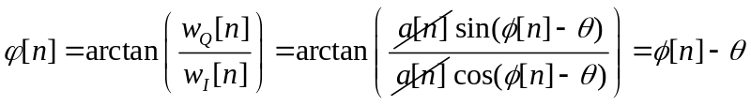
Let us now sum the arctangent values over N time samples that cover, for example, a one second time interval (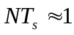second), which leads to the approximation
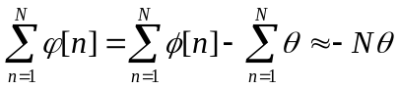
The summation 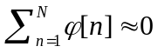because audio signals will generate a sequence over time n of both positive and negative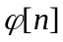 random values with a sum (discrete-time integration) that averages out to zero over time. Thus, if we integrate the arctangent output over time and divide by the number of terms integrated, we obtain a good estimate of the phase offset
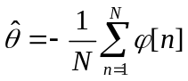

To apply this estimation to separate the two message waveforms in a QAM signal, we will use a two-pass approach. PASS 1: use 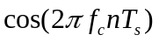and 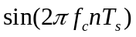as demodulation sinusoidals the first time through the QAM demodulator, form the arctangent samples of roughly a one second data interval in the I and Q branches after the LPF (use a data segment with active voicing for best results), and integrate (sum) the arctangent samples to form an estimate of phase offset [see Figure 1(a)]. PASS 2: use 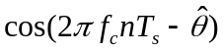and 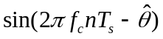as demodulation sinusoidals the second time through the QAM demodulator, which should yield only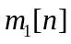in the I-branch and only 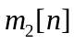in the Q-branch [see Figure 1(b)].

In a practical QAM demodulator, the estimation of the phase offset would be performed continuously on the fly, and the demodulation sinusoidals continuously adjusted for changes in the offset. Instead of an exact arctangent function evaluation, a practical QAM demodulator would use an arctangent approximation that is simpler to implement in digital hardware. The integrator would be replaced with a low-pass filter with only a few Hz bandwidth, which is an approximation to a continuously-running integrator. Figure 1(c) illustrates a practical QAM demodulator/receiver.
